P RK
POWER
Partnering to Fight Hunger in Illinois
Contact IPPA office prior to processing to ensure funds are available.

DONOR INFORMATION
Date of Delivery Farm Name Contact Person
Address

City/State/Zip Phone Email
Total # swine donated Estimated or actual total live weight

Signature

MEAT PROCESSOR USE ONLY

Processing Plant Contact Person & City Authorized signature Date
Donated Hogs Information (completed by Processor)

# Market Hogs # Sows
Carcass Weight Carcass Weight
Trim Weight Trim Weight

Total Carcass Weight of Donated Swine X $.85/lb = Total Amount of Donated Pork

FOODBANK INFORMATION
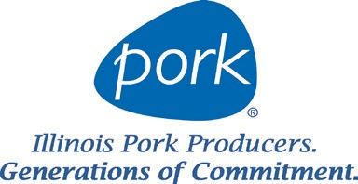
Name of Foodbank Contact Person Phone Number Email
RETURN COMPLETED FORM TO KIM@ILPORK.COM

